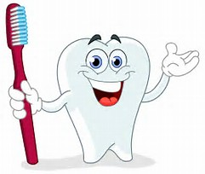
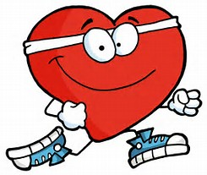
Health and Movement Integration
Julie Smith
SHAPE MT 2018
Julie.smith@bsd7.org

Want to cover health standards and topics in your elementary health enhancement classes, but don’t want students to sit around wasting valuable physical activity time? This session will focus on strategies for teaching health content to k-2 elementary students using fun and effective methods. Explore movement tactics that will support students learning health concepts with minimal sitting time.

Adaptable Activities
- Informal assessment
- Throwing
- Match
- Flash cards

Social Responsibility
- Bucket filler tag
- How to solve problems
- Feelings
- Environmental health

Dental Health
- Teeth brushing relay
Environmental Health
- Earth Day Stations
Substance Use and Abuse
- Safe and Healthy vs Unhealthy and Poisonous
Safety
- Safe and Sorry
- Stop, Drop, Roll Tag
- Winter clothes Relay
- First aid stuffies

Fitness
- Super Hero Fitness
- Physical Activity Tag
- Couch Potato
- Fitness Frenzy

Human Body
- Skeleton Relay
- Healthy Heart obstacle course
Disease and prevention
- Hand Washing Tag
- Germ Tag

Mental and Emotional Health
- Ways to calm down
- Emotions

Nutrition
- Fruit Basket/Salad Bowl
- Food group relay
- Myplate Shuffle
- Food group tag
- Go, Slow, Woah
- Healthy Snack Relay

Additional Strategies
- Visual aides/Bulletin Boards
- Literacy integration
- Essential Questions
- Bozeman’s Health Box system
- Kidshealth.org
- Tell a neighbor

